***INTRODUCTION TO DATABASE ASSIGNMENT***

**Problem Statement: There can be multiple customers, who can place multiple orders on the site. Now a sales person can handle these orders will distribute into multiple sales persons (One order will be assign to one salesperson only). So a sales person can have multiple orders of multiple customers**

1. **Create Database**

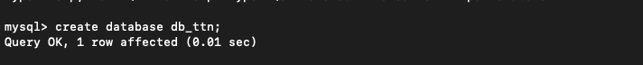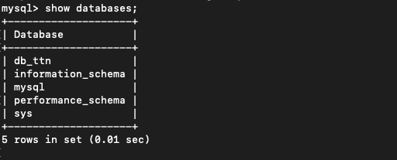

1. **Design Schema**

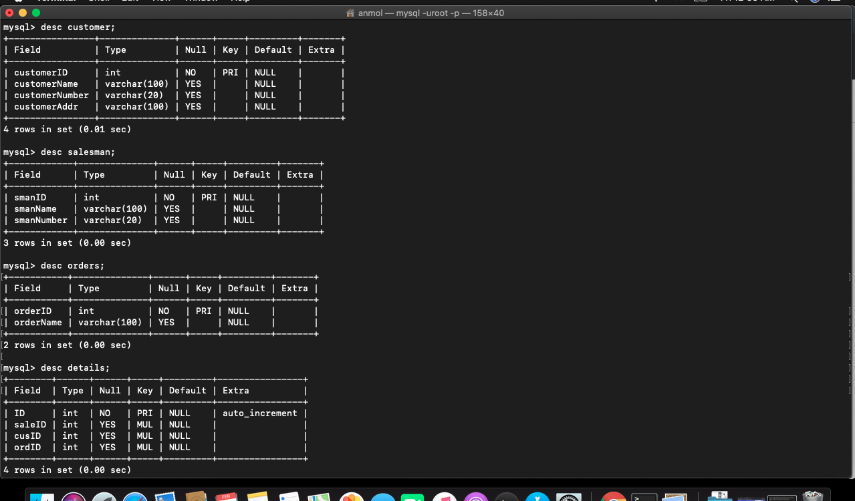

1. **Create tables**

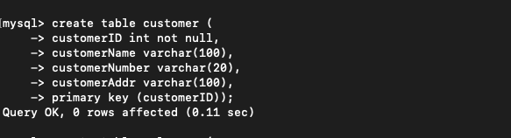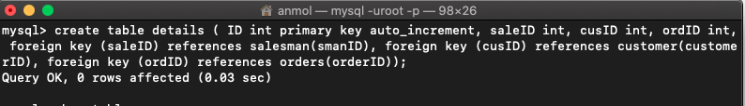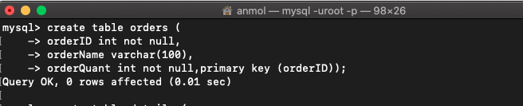

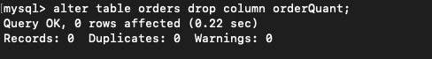



1. **Insert sample data**

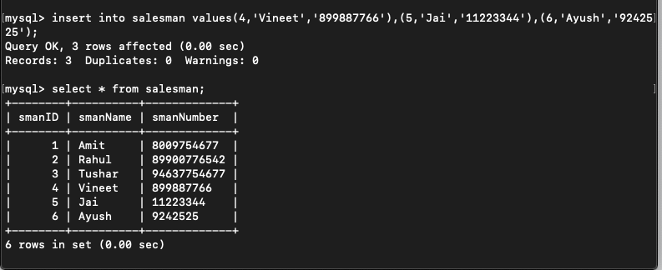

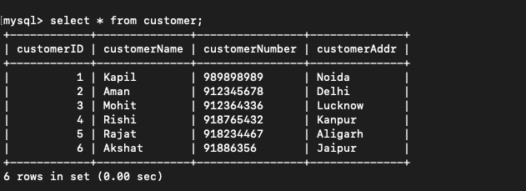

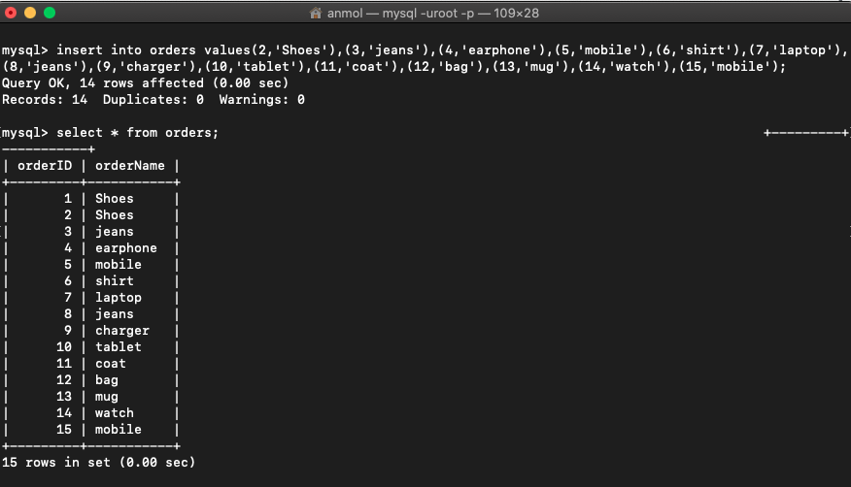

1. **Find the sales person have multiple orders.**

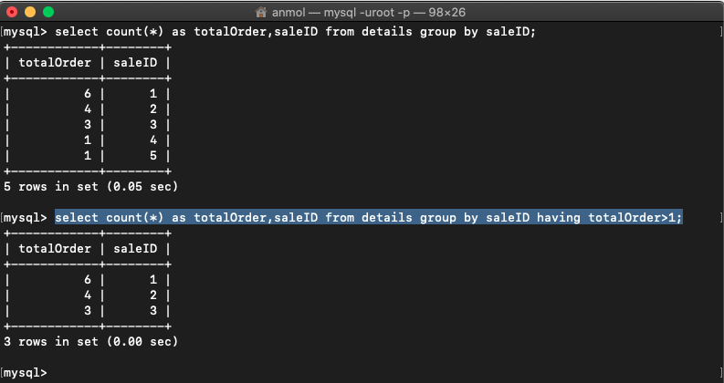

1. **Find the all sales person details along with order details**

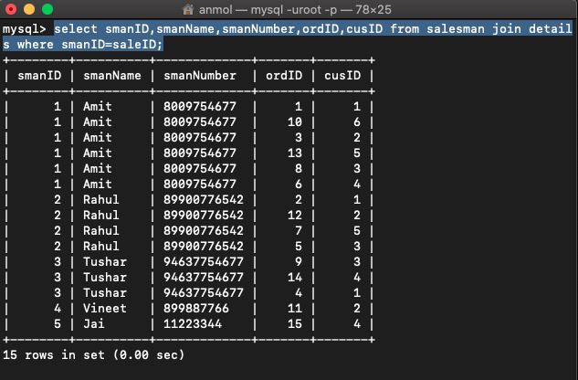

1. **Create index**

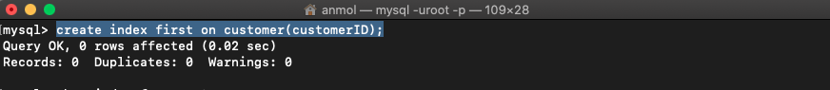

1. **How to show index on a table**

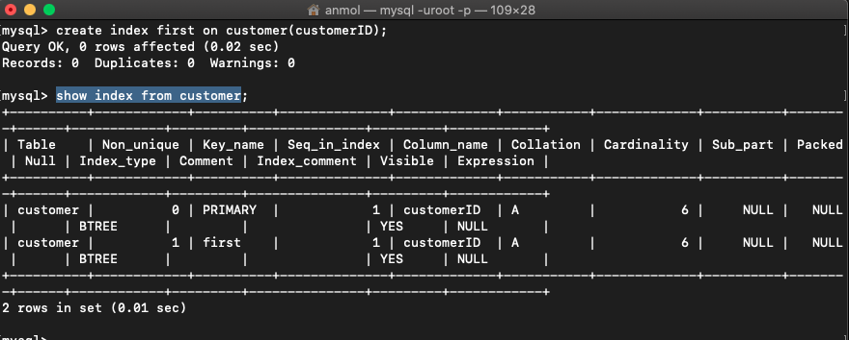

1. **Find the order number, sale person name, along with the customer to whom that order belongs to**